Role of cystinosin in vesicular trafficking and membrane fusion
Final report – February 2013

Research project conducted at Inserm U983 (Necker Hospital, Paris)
Principal investigator: Corinne Antignac
Persons working on the project:
Zuzanna Andrzejewska (PhD student, funded by the Cystinosis Research Foundation)
Nathalie Nevo (technician, Inserm funded)

Background and objectives

The global aim of the research project is to characterize intracellular trafficking of cystinosin and to identify possible novel functions of cystinosin, especially in membrane fusion. The specific aims of the projects are:
1. To characterize how cystinosin is sorted to the lysosome
2. To identify the possible cystinosin partners involved in vesicle fusion

Background:
Previous research demonstrated that cystinosin, the lysosomal cystin transporter, is targeted to the late endosomes and lysosomes by two sorting signals, the classical tyrosine-based GYDQL lysosomal sorting motif in its C-terminal tail, and a novel conformational, localized to the 5th inter-TM loop, both of which are oriented toward the cytoplasm (Cherqui et al, 2001). Indeed, the deletion of the C-terminal tail or 5th inter-TM loop of cystinosin leads to partial relocalization of the protein to the plasma membrane. Moreover, cystinosin is completely relocalized to the plasma membrane when both motifs are altered.We also showed that cells transiently or stably overexpressing a cystinosin-GFP fusion protein display striking aggregation of lysosomes into a few large juxtanuclear structures and a diminution of the usual pattern of small discrete intracytoplasmic vesicles characteristic of lysosomes. The enlarged lysosomes are reminiscent of what is observed in cells overexpressing hVam6p, a protein of the Vamp (Vesicle associated membrane protein) family, which has been identified as a mammalian tethering/docking factor with an intrinsic ability to promote lysosome fusion in vivo. Altogether, this led to the hypothesis that cystinosin has important roles apart from cystine efflux, in particular that it may be involved in intracellular vesicular trafficking and lysosomal fusion, and that these effects might be mediated by its 5th inter-TM loop or the C-terminal tail.
Moreover, little is known about the way the multispanning transmembrane proteins, like cystinosin, are targeted to lysosomes. Four heterotetrameric adaptor protein complexes (AP-1 to AP-4) are involved in selection of cargo molecules in mammalian cells by their ability to recognize the sorting motifs (Robinson and Bonifacino, 2001). The tyrosin-based motif located at the C-terminal tail of cystinosin presents similarities to those contained by proteins interacting with various AP complex sub-units. The studies on lysosomal targeting of lysosome-associated membrane proteins (LAMPs) and of Battenin (CLN3) indicate the existence of different possible pathways by which proteins can be sorted to these organelles mediated by distinct AP complexes. The second part of the project will focus on the cystinosin trafficking to the lysosomes and the role of AP complexes in this process.

Characterization of cystinosin intracellular sorting

As we have reported previously, we identified the interaction of the cystinosin tyrosine-based motif with μ3 (AP3) of AP3 complex in a direct yeast two hybrid screen. The substitution of tyrosine in this motif into alanine abolished the interaction. Moreover, to analyze the role of AP complexes on cystinosin trafficking in a cellular model, we studied the possible mislocalization of cystinosin by immunofluorescence in cell lines depleted in the delta subunit of the AP3 complex. However, our immunofluorescence study in stable Mocha (Δδ AP3) and 3T3 cell lines expressing cystinosin-GFP fusion protein did not show its retention in pre-lysosomal compartment in Mocha cells, analyzed by colocalization with Vti1β (endosomal SNARE protein), as described by Berger et al. for Niemann-Pick Type C proteins. Moreover, to analyze the possible mislocalization of cystinosin to the plasma membrane, we performed cell surface biotinylation studies in Mocha and 3T3 stable cell lines. However, we could not observe any increase in cell surface expression of cystinosin in Mocha CTNS-GFP cell line.
Furthermore, we generated HeLa cells transduced with lentivirus containing shAP3 or shLuciferase (shRNA vectors kindly provided by A. Benmerah), which enables us to analyze the localization of cystinosin and its targeting motif deletion mutants after transient transfection. Our cell surface biotinylation analysis shows partial mislocalization of cystinosin-GFP protein to the plasma membrane in HeLa shAP3 cells 20h after transfection (Fig.1), the result obtained in four independent experiments. Interestingly, this increase could no longer be detected 48h after transfection. Moreover, it seems that both motifs could play a role in a rapid internalization of cystinosin from the plasma membrane, once it is mislocalized, as only the biotinylated cystinosin-GFP can no longer be detected 48h after transfection. This could also explain the lack of signal of biotinylated cystinosin-GFP in stable Mocha cell lines.

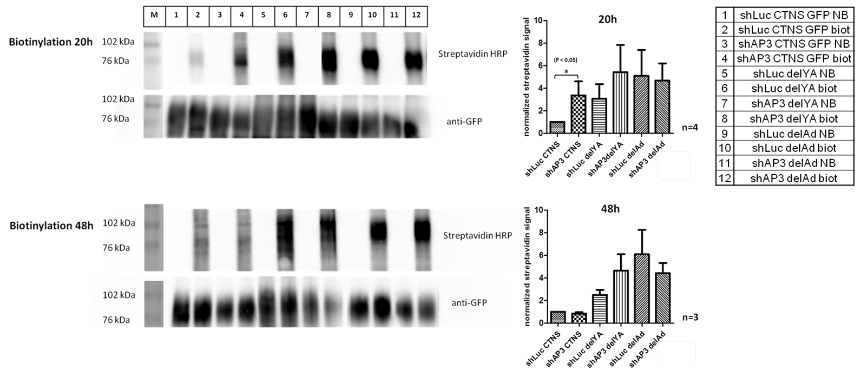
Figure 1: Cell surface biotinylation in HeLa shAP3 and HeLa shLuc 20h or 48h after transfection.
Western blots of biotinylated samples. After cell surface biotinylation, the total cell lysates were immunoprecipitated using GFP coupled beads. The eluates were divided in two and revealed with streptavidin-HRP or anti-GFP antibody (NB-non biotinylaed, biot-biotinylated samples). Results from at least three separate experiments shown.

The use of the TIRF (total internal reflection fluorescence) microscopy enabled us to further confirm our cell surface biotinylation results obtained in HeLa shAP3 cell line. TIRF, or evanescent field microscopy, is a form of fluorescence microscopy where excitation light is confined to a small area at the interface of the specimen and the culture dish, typically less than 100 nm thick, thus allowing observation of phenomena occurring at, or near of, the cell surface. We performed cotransfections of HeLa shAP3 or HeLa shLuc with cystinosin-GFP or lysosomal targeting motif deletion mutant constructs together with farnesylated monomeric DsRed (DsRed-Monomer-F, constructs kindly provided by A.Benmerah) as a control for cell surface localization. Living cells were observed 20h after transfection and corrected total fluorescence at the plasma membrane was quantified with ImageJ analysis program. As for the biotinlylation study, the increase in cell surface expression of cystinosin-GFP was observed (Fig.2).
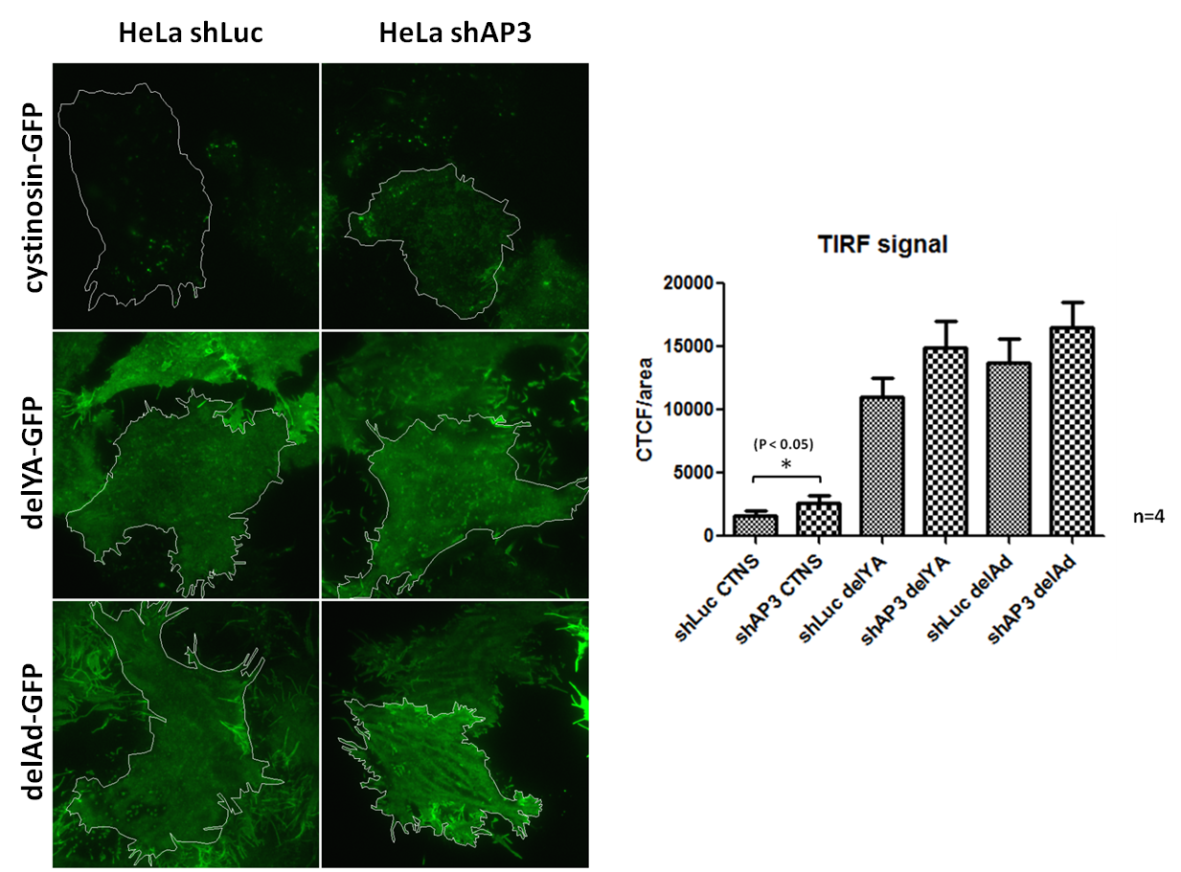
Figure 2: TIRF analysis of cell surface expression of cystinosin-GFP and its targeting motif deletion mutants in HeLa shAP3 and HeLa shLuc 20h after transfection. Results from four separate experiments shown.
Corrected total cell fluorescence (CTCF) = Integrated Density – (Area of selected cell x Mean Fluorescence of background readings)

Identification of cystinosin interaction partners

In order to get insight into the possible implication of the 5th inter-TM loop of cystinosin, this domain was used for a large screen against a mouse kidney cDNA library (collaboration with Hybrigenics). We identified different putative partners and focused Snf8 (the murine homolog of Vps22) implicated in membrane trafficking (Progida et al, 2006). To confirm the possible interaction with SNF8 we prepared the construct for production of SNF8-GST fusion protein. As mentioned in the previous report, we encountered some problems in optimization of pull down conditions for cystinosin-GFP and cystinosin-HA, as signals for these proteins could be observed also in eluates after pull down with GST alone, thus we could not definitely conclude for the presence of the interaction with SNF8.

Conclusion:
We have shown, by yeast two-hybrid assay, that the tyrosine-based motif of cystinosin interacts with the µ3 subunit of the AP3 complex involved in direct targeting of lysosomal proteins to the lysosomal membrane. We confirmed the impact of AP3 on cystinosin targeting by cell surface biotinylation study and TIRF analysis, showing partial cystinosin mislocalization to the plasma membrane of HeLa shAP3 cells. Moreover, as reported previously, the cystinosin tyrosine-based motif seems to have an impact on the targeting of CD63, leading to increase in intracellular localization of a chimera protein made of CD63 with the C-terminus part of cystinosin (CD63-CTer GFP) when compared to CD63-GFP.
We will are now completing the study by the analysis of the localization of cystinosin-GFP and its deletion mutants in HeLa cells depleted for AP1 or AP2 as we were successful in generating HeLa shAP1 and HeLa shAP2 cell lines.

References:

- Caplan S, Hartnell LM, Aguilar RC, Naslavsky N, Bonifacino JS, Human Vam6p promotes lysosome clustering and fusion in vivo. JCB 154(1): 109-121, 2001
- Cherqui S, Kalatzis V, Trugnan G, Antignac C, The targeting of cystinosin to the lysosomal membrane requires a tyrosin-based signal and a novel sorting motif., JBC 276: 13314-13321, 2001
- Dell'Angelica EC, Shotelersuk V, Aguilar RC, Gahl WA, Bonifacino JS. Altered trafficking of lysosomal proteins in Hermansky-Pudlak syndrome due to mutations in the beta 3A subunit of the AP-3 adaptor., Mol Cell.;3(1):11-21., 1999

Furuta N, Fujita N, Noda T, Yoshimori T, Amano A, Combinational soluble N-ethylmaleimide-sensitive factor attachment protein receptor proteins VAMP8 and Vti1b mediate fusion of antimicrobial and canonical autophagosomes with lysosomes., Mol Biol Cell.; 15;21(6):1001-10; 2010
- Progida C, Spinosa MR, De Luca A, Bucci C, RILP interacts with the VPS22 component of the ESCRT-II complex, Biochem Biophys Res Commun. 347(4):1074-9, 2006
- Robinson MS, Bonifacino JS. Adaptor-related proteins., Curr Opin Cell Biol.13(4):444-53,2001
- Rous BA, Reaves BJ, Ihrke G, Briggs JA, Gray SR, Stephens DJ, Banting G, Luzio JP Role of adaptor complex AP-3 in targeting wild-type and mutated CD63 to lysosomes., Mol Biol Cell.;13(3):1071-82, 2002

