Cystinosis research Foundation, 18 month progress report

STUDYING PODOCYTE FUNCTION IN NEPHROPATHIC CYSTINOSIS

Ivanova Ekaterina, doctoral student
Elena Levtchenko , MD, PhD, principal investigator

Pediatric Nephrology, University of Leuven
Herestraat 49, 3000 Leuven, Belgium

Background

The capillary wall of the glomerulus is composed of glomerular endothelial cells, the glomerular basement membrane and podocytes, and is responsible for selective plasma filtration by the kidney. The three layers of the glomerular filter function in a continuous interplay, in which a central role of podocytes being increasingly recognized during the last decennium (Patrakka and Tryggvason 2009). Numerous kidney diseases leading to end-stage renal failure affect the glomerular filtration barrier and are associated with proteinuria.
Cystinosis is an autosomal recessive disorder caused by mutations in the CTNS gene that encodes a lysosomal cystine transporter and results in high cystine levels in the patients’ lysosomes. A major consequence of cystinosis is the development of severe renal disease, characterized by general proximal tubular dysfunction (renal Fanconi syndrome) progressing towards end-stage renal failure. Patients with cystinosis typically have high levels of cystine in their lysosomes. Despite the general belief that renal proximal tubular cells are the primary targets in cystinosis, several lines of evidence, such as the presence of glomerular proteinuria and morphologic podocyte changes, point to early podocyte dysfunction in this disorder (Wilmer et al. 2008). Enhanced cell death due to apoptosis and autophagy has been suggested to be involved in the pathogenesis of cystinosis as well (Park et al. 2006; Sansanwal et al. 2010). Remarkably, podocytes exhibit the highest level of autophagy in the human nephron (Hartleben et al. 2010). Although autophagy is generally considered as a protective mechanism, both extensive and defective autophagy can induce or contribute to cell death. Whether dysregulation of autophagy/apoptosis plays a role in podocyte (and glomerular filtration barrier) dysfunction in cystinosis remains unclear.
Studying the glomerular pathogenesis of cystinosis is hampered by the absence of human podocyte cell lines carrying the mutations in the CTNS gene. Renal tissue of patients with cystinosis is generally not available, because renal biopsies are not performed to establish the diagnosis of cystinosis. Recently, however, we were successful in developing conditionally immortalized podocyte cell lines from exfoliated cells in urine of cystinotic patients (diagnosis was confirmed by molecular analysis of CTNS gene) and healthy controls, in collaboration with Prof. Dr. M. Saleem (Southmead Hospital, Bristol, UK).

Specific Aims

In this project we will explore the hypothesis that aberrations in podocytes contribute to the development of proteinuria and glomerular damage in nephropathic cystinosis. The following key-objectives will be addressed:
A. To extend the number, and to further characterize podocyte cell cultures from cystinosis patients and controls. To establish cystinotic podocyte cell lines using shRNA approach.
B. To investigate the effect of CTNS-deficiency on podocyte cell viability, apoptosis and autophagy.
C. To assess the consequence of increased cystine levels on podocyte barrier function.

D. To study the potential rescue of podocyte damage by treatment of cystinotic podocytes with cysteamine or inhibitors of the renin-angiotensin system, or by knock-in of the CTNS gene.
By addressing these key objectives we will increase our insight into the pathogenesis of glomerular dysfunction in cystinosis and hope to be able to propose a more effective treatment.

Results
A. We have established stable podocyte cell lines deriving from urine sediments of 3 healthy volunteers and 9 cystinosis patients. All cells were immortalized using a temperature-sensitive viral vector for conditional immortalization, subcloned and characterized by the presence of specific podocyte markers (CD2AP, synaptopodin, nephrin and podocin). Based on this characterization and the levels of cystine accumulation, we selected two control and two cystinotic cell lines derived from different donors to lower the possibility of cell line-specific effects for performing further studies.

Table 1. Characterization of conditionally immortalized podocyte cell lines deriving from urine sediments of healthy volunteers and cystinotic patients selected for the future studies.

Cell line | Genotype | Cystine content | Podocin | Nephrin | CD2AP | Synaptopodin
10-098/4 | Control | 0.06 | + | ++ | + | +
11-033/4 | Control | 0.73 | ++ | + | + | +
10-119/9 | CTNS hom 57 kb del | 25.64 | + | + | + | +
11-014/4 | CTNS 57 kb del + c.926 dup | 12.96 | + | + | + | +

Additionally control podocyte cell line AB developed from kidney tissue and described earlier by prof. dr. M.A. Saleem (Southmead Hospital, Bristol, UK) is included. We have performed a set of CTNS gene knock-down experiments, using this human podocyte cell line. Several lentiviral constructs for expression of various shRNA sequences were tested (together with non-specific controls). These cells are currently analyzed for cystine accumulation and CTNS expression by means of qPCR to confirm the knock-down efficiency.

B. An increased podocyte motility has been described to result in proteinuria. We investigated directed motility of control and cystinotic podocyte cells by means of wound healing assay. Briefly, cells were grown on glass coverslips until reaching a subconfluent monolayer and incubated at 37°C for 7 days to ensure differentiation. A uniform scratch was made in the monolayer and the cells were fixed after 18 hours. The number of cells migrated into the wound was counted in 2 independent experiments, each performed on 3 coverslips; minimum 5 fields of view per cell line per experiment were analyzed. We found that more cystinotic podocytes migrated into the scratch zone, indicating a more motile phenotype (see Figure 2, p<0.05).

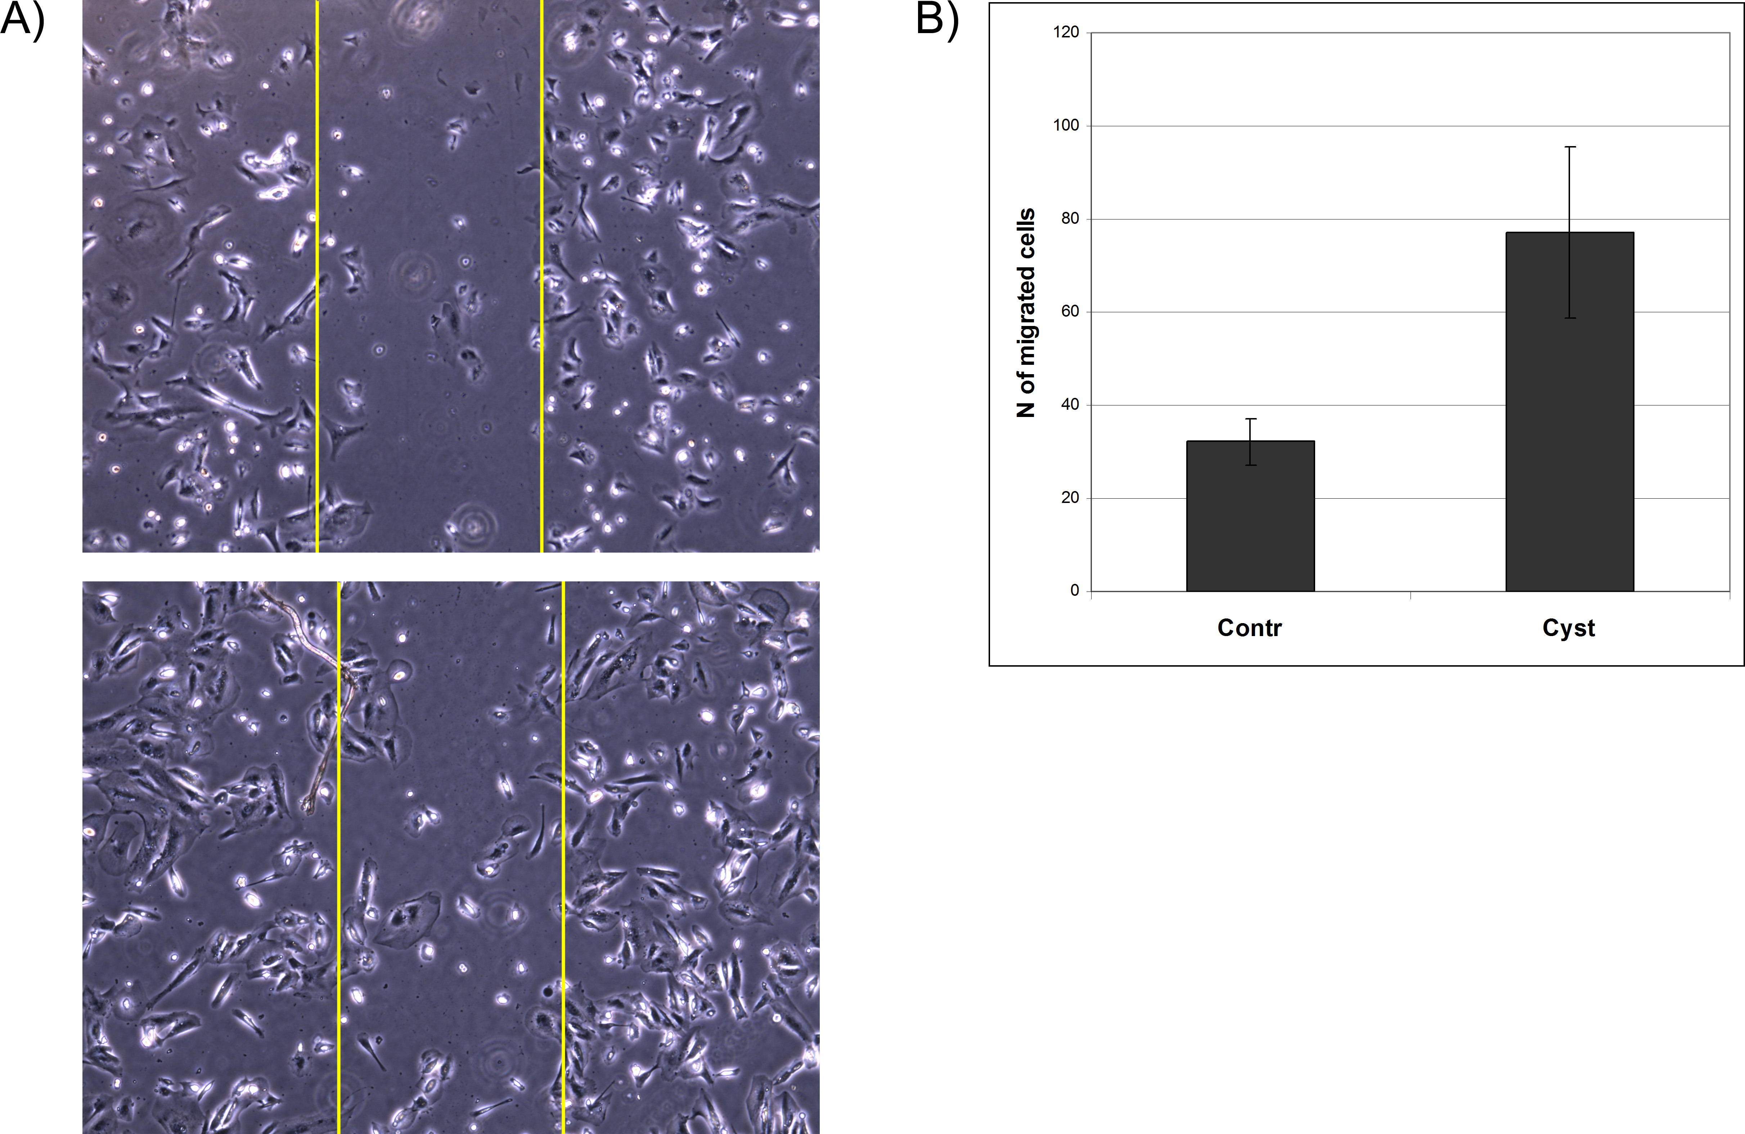

Figure 2. Motility assessment using wound healing assay. A) Representative images of control (above) and cystinotic (below) cells migrating into the wound after 18 hours. B) Quantification of motility based on 2 independent experiments (p<0.05).

C. In order to visualize podocyte cytoskeleton in control and cystinotic cells, we performed a phalloidin staining of both proliferating (33°C) and differentiating cells (7 days at 37°C) (Figure 3). We found that staining pattern in differentiated cystinotic cells was different, showing node-like structures next to typical actin cortical fibers. We continue to investigate cytoskeleton changes in cystinotic vs control cells to reveal possible link with the increased cell motility.

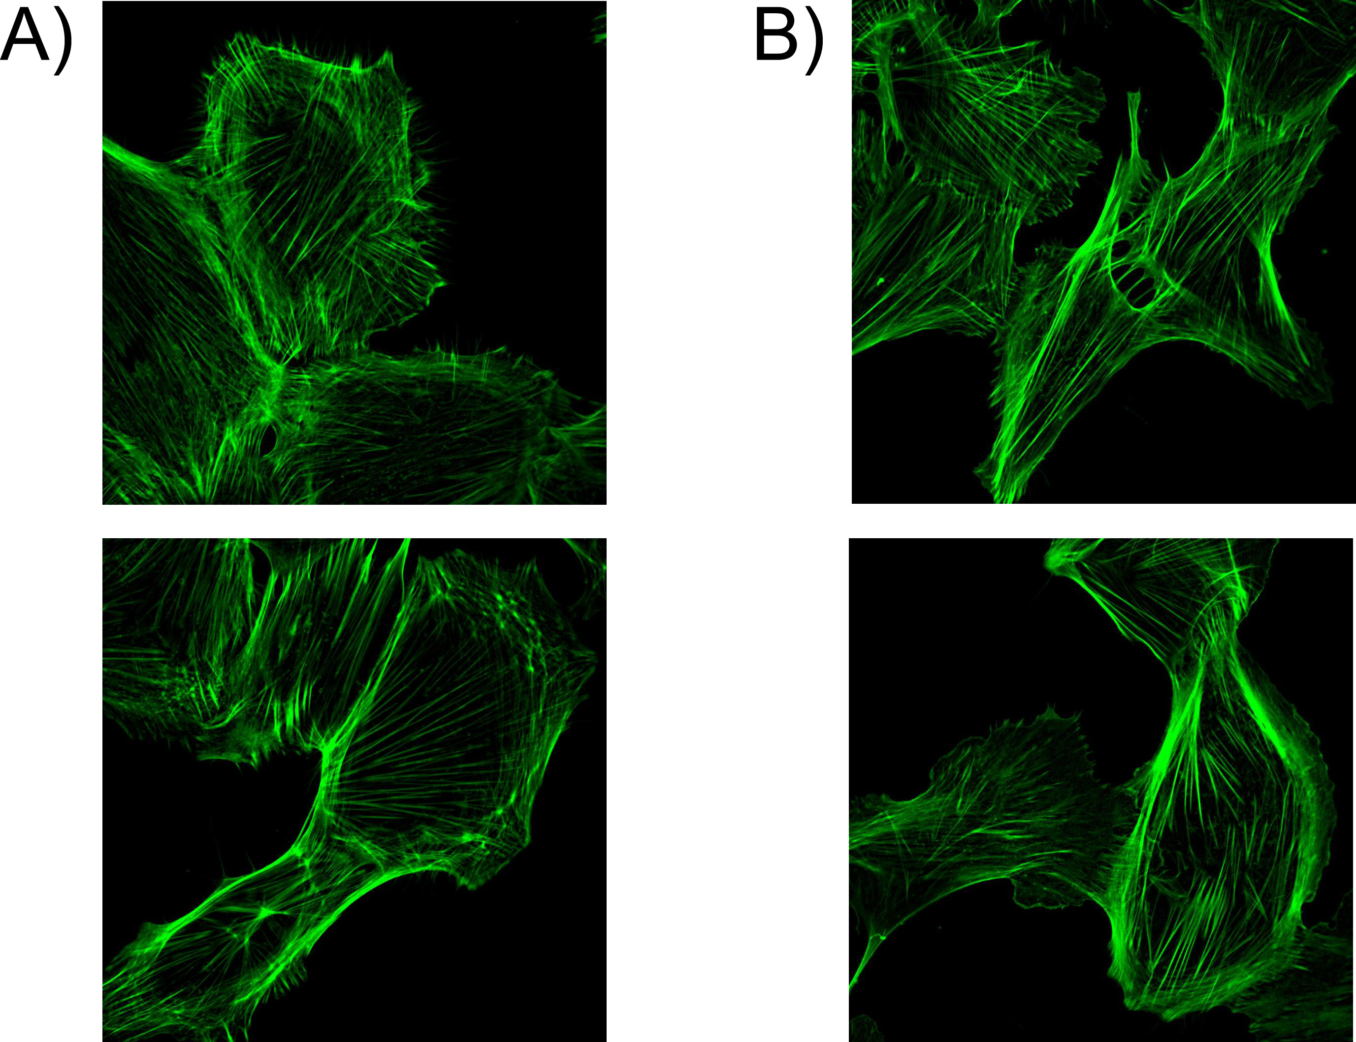
Figure 2. Phalloidin staining of actin cytoskeleton of control (upper panel) and cystinotic (lower panel) podocytes, fixed after differentiation at 37°C (A) and during cell proliferation at 33°C (B).

D. In order to demonstrate and to quantify podocyturia in cystinosis patients, we collected fresh urine samples from cystinosis patients in Belgium and in the Netherlands. At the same time, we will also analyse the presence of proximal tubular cells in urine using specific proximal tubular markers.

Because accurate characterisation of cellular content of urine is a challenging task due to great variation in quantity and quality of the samples, we combine 3 approaches to achieve this goal:

- Measurement of podocyturia by qPCR.
Several groups reported successful measurement of podocyte markers in patients’ urine by means of qPCR. This method has a number of advantages such as relatively easy and reliable quantification protocols (using standard curves), possibility to store the samples and re-use them to test other genes if needed. The preliminary experiments performed in our lab showed that podocyte markers CD2AP and synaptopodin were readily detectable in RNA extracted from urine using a standard method (Quiagen RNEasy miniprep kit). As little as 20 podocytes per ml urine could be detected (see Figure 3). The markers were present in samples obtained from 2 non-transplanted cystinosis patients and absent in 2 healthy controls. However, we need more data on the specificity of this test. It cannot be excluded that the detected mRNA originated not from the excreted viable podocytes, but from cell fragments or microvesicles. We will continue collecting RNA samples from urine of accessible cystinosis patients. Real time PCR will be performed on samples that were positive for the studied markers for accurate quantitative measurements.

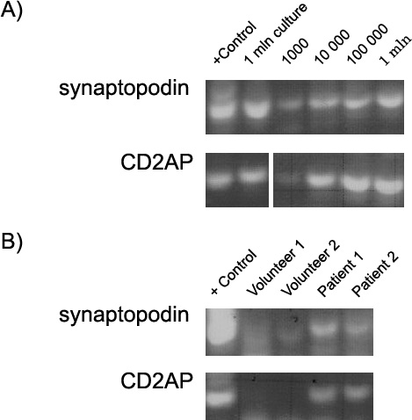
Figure 3. PCR analysis demonstrating the presence of podocyte-specific markers in urine sediments. A) Sensitivity test: cultured human podocytes were incubated at 37°C for 7 days to ensure differentiation, RNA was extracted from 1 million of cells and from specimens of cell-free human urine (50 ml) with added 1000, 10000, 100000 and 1 million of cells to mimic the real situation and PCR analysis was performed. B) RNA was extracted from urine sediments of 2 healthy volunteers and 2 cystinosis patients and PCR analysis of podocyte-specific markers was performed.

- Immunocytochemistry analysis of dried urine sediments.
Samples of urine sediment were obtained from each patient, fixed in 4% PFA and air-dried on glass coverslips. These coverslips were later used for specific staining of podocyte markers and estimation of the percentage of positive cells. We have already performed a set of immunostainings with a monoclonal anti-synaptopodin antibody using samples obtained from a healthy control and a patient with diabetic nephropathy (Figure 4). We are currently testing another specific podocyte marker – podocalyxin - using a commercially available monoclonal antibody. In total, 2 specific podocyte markers will be used to estimate the abundance of this cell type in urine sediments and the results will be compared and combined. Whole cells will be distinguished from the debris by nuclear staining.

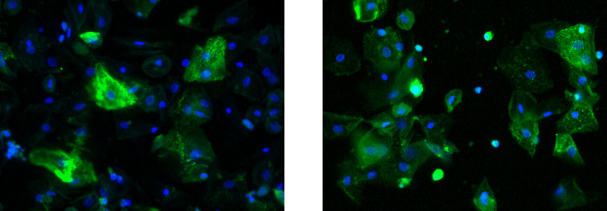
Figure 4. Representative anti-synaptopodin immunostaining of urine sediments obtained from a healthy volunteer (left panel) and a patient with diabetic nephropathy (right panel) showing higher amount of synaptopodin-positive cells in a patient with diabetes.

- FACS analysis.
This approach is very attractive because it allows direct specific detection and quantification of podocytes and other cells present in urine sediment. However, the samples cannot be stored for a long time, and it is not evident whether they can be safely transported and under what conditions. Therefore, we will perform a number of pilot experiments to optimize this method.

On the basis of the preliminary experiments and relative success of the three approaches we will choose the most reliable combination of techniques for quantification of podocyturia in cystinosis patients. RNA samples and dried coverslips will be stored from each patient to be used in the future for additional experiments.

