Parthenogenetic embryonic stem cells as a source of immunocompatible renal progenitor cells for therapy of nephropathic cystinosis

Principal Investigator:
Holger Willenbring, MD
The Eli and Edythe Broad Center for Regeneration Medicine and Stem Cell Research Department of Surgery, Division of Transplantation
University of California San Francisco
513 Parnassus Avenue
San Francisco, CA 94143

Co-Investigator: K. John McLaughlin, PhD
Center for Animal Transgenesis and Germ Cell Research/Department of Animal Biology, The School of Veterinary Medicine
University of Pennsylvania
New Bolton Center
382 West Street Road
Kennett Square, PA 19348

Period of funding: 03/2008 - 02/2010

The goal of this research project is to achieve therapy of a mouse model of renal Fanconi syndrome (as it develops in nephropathic cystinosis) with kidney progenitors derived from immunocompatible pluripotent stem cells, specifically parthenogenetic embryonic stem cells (pESC) derived from mouse oocytes. For this purpose, we are (1) developing a cell culture protocol effective at directing pESC towards renal progenitor differentiation and we are (2) establishing a mouse model of renal Fanconi syndrome to test the therapeutic efficacy of the differentiated pESC. In the following, we describe the progress we have made towards achieving these aims.

Aim 1: Generation of kidney progenitors from pESC.

Aim 1.1: Derivation of pESC from oocytes carrying a reporter gene indicating mesodermal specification.

Our differentiation culture is based on a previously described protocol that uses mouse ESC with EGFP knocked into the brachyury (T) locus (T-EGFP^{+/-}). This system enabled the identification of ESC that acquired mesodermal specification. In addition, these ESC carried a β-galactosidase marker gene for tracking after transplantation (Rosa26^{+/-}, T-EGFP^{+/-}). To generate pESC expressing the same marker genes, we have obtained T-EGFP^{+/-} mice and are currently breeding these with Rosa26^{+/-} mice to generate a cohort of female mice as oocyte donors for the derivation of pESC. As soon as a sufficient number of female Rosa26^{+/-}, T-EGFP^{+/-} mice is available, we will begin to derive pESC. To be able to establish cell culture conditions for renal differentiation of pESC during the time needed for expanding these mice, we have obtained the original Rosa26^{+/-}, T-EGFP^{+/-} ESC (Figure 1).

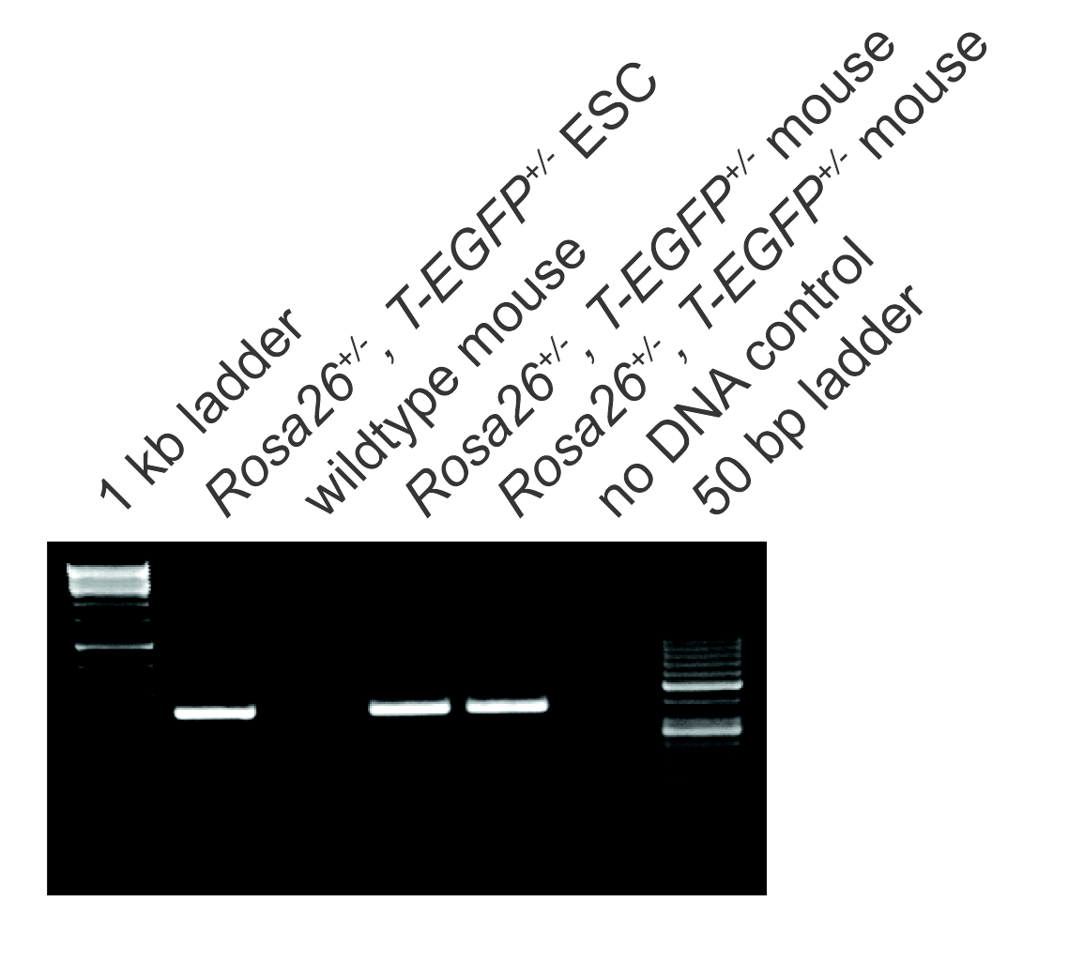
Figure 1: Genotyping (EGFP-PCR) of Rosa26^{+/-}, T-EGFP^{+/-} mice and ESC.

Aim 1.2: Differentiation of pESC into kidney progenitors in culture.

Rosa26^{+/-}, T-EGFP^{+/-} ESC were weaned of feeders and maintained under feeder-free and serum-free conditions on ultra low attachment plates. ESC were converted into embryoid bodies (EB) by removing LIF from the ESC medium. Subsequent culture in medium supplemented with Activin-A was used to induce mesodermal specification of EB cells. After several modifications of the original protocol, we were able to induce the characteristic pattern of initial up-regulation followed by down-regulation of brachyury expression in the ESC-derived cells (Figure 2). Brachyury is induced as cells commit to mesodermal specification but declines with further renal differentiation. As expected, progressive ESC differentiation was accompanied by loss of the pluripotency marker Oct-4. We are currently in the process of enriching the lineage-committed cells and optimizing their renal differentiation.
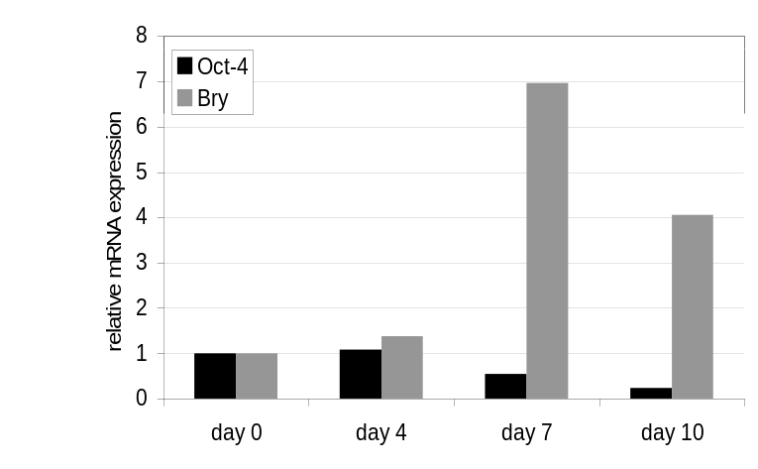
Figure 2: Quantitative reverse transcription PCR for brachyury and Oct-4 shows step-wise (day 0 to day 10) specification of cells in EB into mesoderm and further differentiated progenitors under culture conditions promoting renal differentiation.

Aim 2: Evaluation of the therapeutic potential of pESC-derived kidney progenitors.

Aim 2.1: Transplantation of pESC-derived kidney progenitors into a mouse model of Fanconi syndrome to determine their function, proliferative capabilities, longevity and safety.

Since the mouse model of cystinosis does not recapitulate the kidney injury of the human disease, an alternative model is needed to test the therapeutic effectiveness of kidney cell therapy with derivatives of pESC. We proposed to induce renal Fanconi syndrome in Fah^{-/-} mice by diverting tyrosine degradation from hepatocytes to proximal renal tubular cells. For this purpose, we aimed at repopulating the livers of Fah^{-/-} mice with Hgd^{-/-} hepatocytes (which are Fah^{+/+}). In doing so, homogentisic acid, the substrate of HGD, will be diverted from hepatocytes to renal proximal tubular cells, the other cell type in the body capable of tyrosine degradation due to expression of the necessary enzymes including FAH. Renal proximal tubular cells remain FAH-deficient under these circumstances. Hence, these cells can be expected to encounter progressive damage due to the accumulation of homogentisic acid-derived metabolites.
When we transplanted hepatocyte suspensions isolated from Hgd^{-/-} mice into Fah^{-/-} recipients, we failed to observe liver repopulation, most likely due to immune rejection of the transplanted cells. Since Hgd^{-/-} mice are on a pure C57Bl/6 strain background, the donor cell rejection was most likely caused by insufficient C57Bl/6 strain purity of our Fah^{-/-} mice. (The Fah^{-/-} mouse was originally generated in the 129S4 mouse strain. Hence, donor cells and recipient mice might differ in minor histocompatibility antigens.) To overcome this problem, rather than performing time-consuming back-breeding of the Fah^{-/-} mice, we used immunodeficient Fah^{-/-}, Rag2^{-/-}, γ_{c}^{-/-} mice recently established in our mouse colony. After optimizing the postoperative antibiotic regimen, we achieved the desired progressive liver repopulation with hepatocytes from Hgd^{-/-} mice in these animals (Figure 3). Based on our previous experience with this mouse model we expect liver repopulation to be complete at 6 weeks after transplantation. At that point we will begin screening these mice for signs of renal Fanconi syndrome including aminoaciduria (serine) and proteinuria. For this purpose, we have established in our laboratory an assay for the quantification of total protein in the urine (Figure 4).

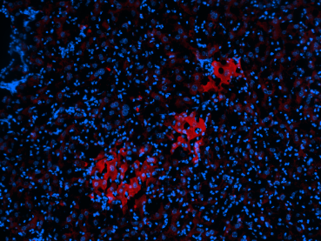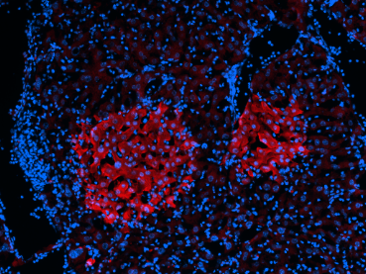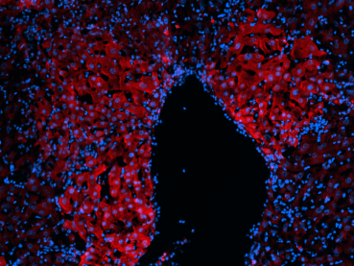
Figure 3: Progressive repopulation of livers of Fah^{-/-}, Rag2^{-/-}, γ_{c}^{-/-} mice with donor Hgd^{-/-} hepatocytes injected into the spleen. The donor hepatocytes have normal Fah alleles, hence express FAH (red immunostaining). Livers were analyzed at 2, 3 and 4 weeks after transplantation.

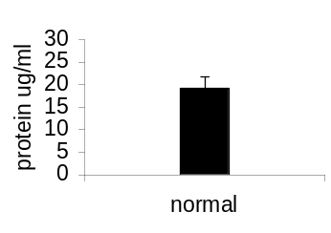
Figure 4: Normal range of proteinuria in the Fah^{-/-}, Rag2^{-/-}, γ_{c}^{-/-} mouse strain used as recipients for the newly established model for renal Fanconi syndrome.

Aim 2.2: Transplantation of kidney progenitors derived from C57Bl/6 pESC into F1 hybrids of C57Bl/6 and Balb/c mice to determine the impact of hybrid resistance on kidney cell therapy.

We have not performed experiments pertaining to this sub-aim yet.

