Cystinosis research Foundation, 6 months progress report

STUDYING PODOCYTE FUNCTION IN NEPHROPATHIC CYSTINOSIS

Karen Peeters, PhD, postdoctoral researcher
Elena Levtechenko , MD, PhD, principal investigator

Pediatric Nephrology, University of Leuven
Herestraat 49, 3000 Leuven, Belgium

Background

The capillary wall of the glomerulus is composed of glomerular endothelial cells, the glomerular basement membrane and podocytes, and is responsible for selective plasma filtration by the kidney. The three layers of the glomerular filter function in a continuous interplay, in which a central role of podocytes is increasingly recognized during the last decennium (Patrakka and Tryggvason 2009). Numerous kidney diseases leading to end-stage renal failure affect the glomerular filtration barrier and are associated with proteinuria.
Cystinosis is an autosomal recessive disorder caused by mutations in the CTNS gene that encodes a lysosomal cystine transporter and results in high cystine levels in the patients’ lysosomes. A major consequence of cystinosis is the development of severe renal disease, characterized by general proximal tubular dysfunction (renal Fanconi syndrome) progressing towards end-stage renal failure. Patients with cystinosis typically have high levels of cystine in their lysosomes. Despite the general belief that renal proximal tubular cells are the primary targets in cystinosis, several lines of evidence, such as the presence of glomerular proteinuria and morphologic podocyte changes, point to early podocyte dysfunction in this disorder (Wilmer et al. 2008). Enhanced cell death due to apoptosis and autophagy has been suggested to be involved in the pathogenesis of cystinosis (Park et al. 2006; Sansanwal et al. 2010). Remarkably, podocytes exhibit the highest level of autophagy in the human nephron (Hartleben et al. 2010). Although autophagy is generally considered as a protective mechanism, both extensive and defective autophagy can induce or contribute to cell death. Whether dysregulation of autophagy/apoptosis plays a role in podocyte (and glomerular filtration barrier) dysfunction in cystinosis remains unclear.
Studying the glomerular pathogenesis of cystinosis is hampered by the absence of human podocyte cell lines carrying the mutations in the CTNS gene. Renal tissue of patients with cystinosis generally is not available, because renal biopsies are not performed to establish the diagnosis of cystinosis. Recently, however, we were successful in developing conditionally immortalized podocyte cell lines from exfoliated cells in urine of cystinotic patients (diagnosis was confirmed by molecular analysis of CTNS gene) and healthy controls, in collaboration with Prof. Dr. M. Saleem (Southmead Hospital, Bristol, UK).

Specific Aims

In this project we will explore the hypothesis that aberrations in podocytes contribute to the development of proteinuria and glomerular damage in nephropathic cystinosis. The following key-objectives will be addressed:
A. To extend the number, and to further characterize podocyte cell cultures from cystinosis patients and controls. To establish cystinotic podocyte cell lines using shRNA approach.

B. To investigate the effect of CTNS-deficiency on podocyte cell viability, apoptosis and autophagy.

C. To assess the consequence of increased cystine levels on podocyte barrier function.

D. To study the potential rescue of podocyte damage by treatment of cystinotic podocytes with cysteamine or inhibitors of the renin-angiotensin system, or by knock-in of the CTNS gene.

By addressing these key objectives we will increase our insight into the pathogenesis of glomerular dysfunction in cystinosis and hope to be able to propose a more effective treatment.

Results

A. We have isolated cells from urine sediments from 2 healthy volunteers and 5 cystinosis patients up till now. All cells were immortalized and subcloned and characterized to make sure they were podocytes.
Nephrin and Podocin Western blots were performed to evaluate expression of these 2 podocyte markers on protein level. Representative blots are shown in figure 1.

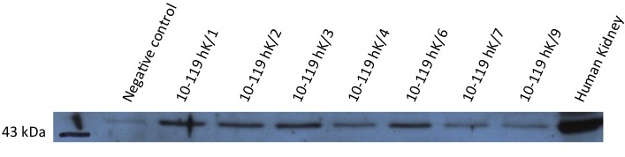
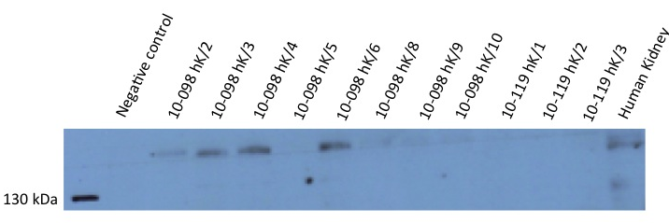

Figure 1: Representative western blot for podocin (42 kDa) (upper panel) and nephrin (135 kDa) (lower panel) for several cell lines isolated from urine sediments. Equal loading was verified by a GAPDH western blot.

Podocin, nephrin (experiment is ongoing), CD2AP and synaptopodin RT-PCR was performed on cDNA to evaluate expression of these markers on RNA levels. A respresentative picture for the CD2AP and synaptopodin RT-PCR is shown in figure 2.

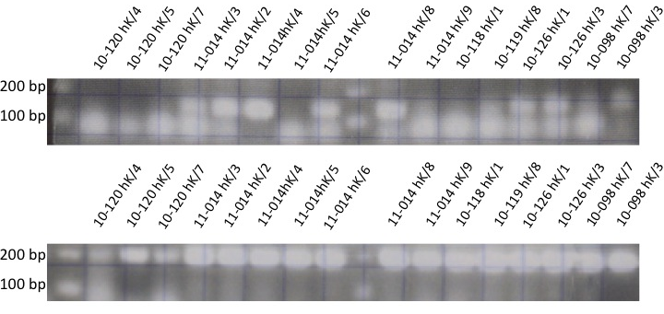
Figure 2: Representative figure for the CD2AP (upper panel) and synaptopodin (lower panel) RT-PCR on cDNA of established cell lines. The CD2AP PCR product is 122 bp long, the synaptopodin PCR product 182 bp.

Immunostainings were performed on some clones to confirm the podocyte phenotype. In Figure 3 an immunostaining for synaptoptopodin (red) and nephrin (green) is shown.

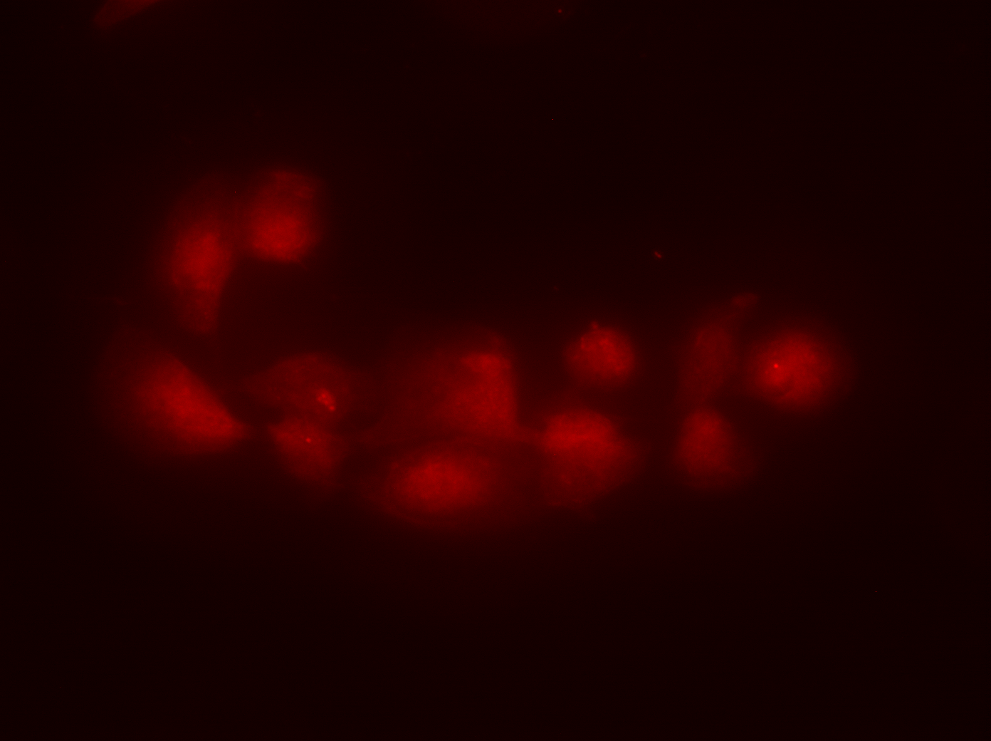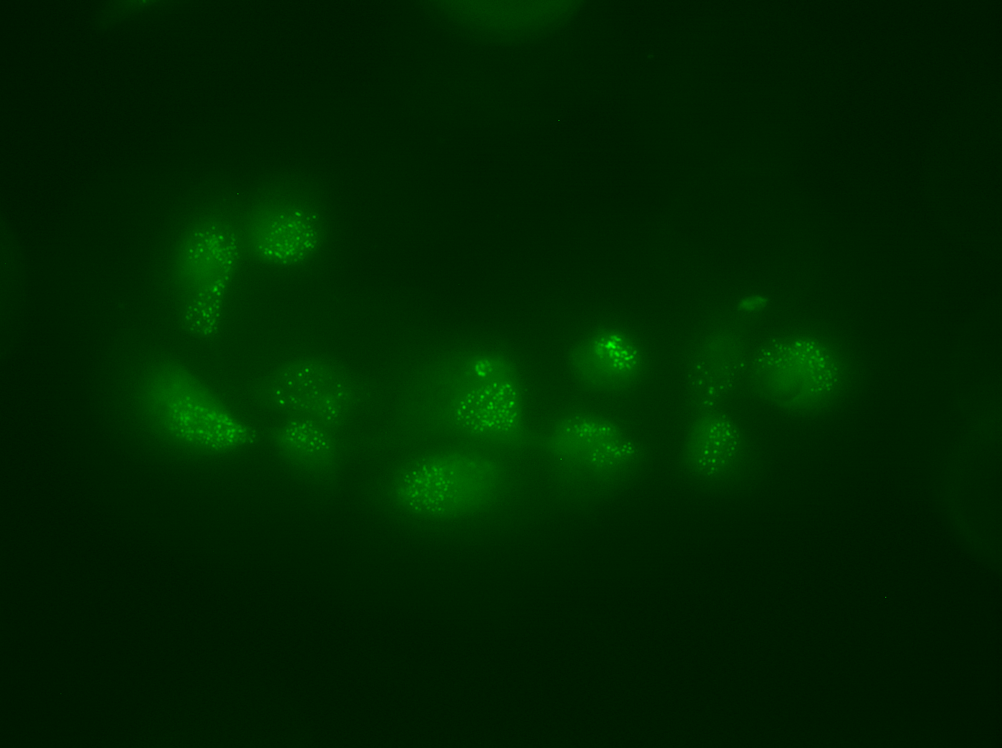
Figure 3: Immunostaining for synaptopodin (red) and nephrin (green) of a subclone of podocyte established from the urine of a healthy volunteer.

Moreover, cells were cultured for 10 days on 37°C after which cystine levels were determined to evaluate the cystinosis phenotype.

Of each cell line, the best podocyte subclones will be selected based on the expression of the podocytes markers and cystine accumulation to continue the experiments with. All data are summarized in Table 1.

We already made the lentiviral shRNA construct that will be used to knock-out the CTNS gene in order to establish a cystinotic podocyte cell line. The podocyte cell line that will be used for knocking out CTNS is a well characterized human podocyte cell line provided by prof. dr. M.A. Saleem, Southmead Hospital, Bristol, UK. This cell line was obtained from a nephrectomy specimen. The efficacy of this construct has been tested in proximal tubular epithelial cells (PTEC). Knocking-out of the CTNS gene was quantified by measuring the cystine levels in these cells. The transduction of PTEC cels with this shRNA construct resulted in a significant elevation of cystine, reflecting the cystinotic phenotype.

B. Selected cell lines will be cultured in order to determine the redox state. Cystinotic podocytes will we compared with control podocytes (experiment is ongoing).

Table 1: Characterization of the podocyte cell lines. Summarized data of the established podocyte cell lines isolated from urine sediments. Several subclones (marked as /1 for instance) were made from each urine donor. The best clones will be used in the future to continue the experiments with. Cystine content is given in nmol/mg protein.

Genotype | DOB | Sex | Clone | Podocin WB | Nephrin WB | Podocin qPCR | Nephrin qPCR | Cystine content | WT-1 qPCR | CD2AP qPCR | Synaptopodin qPCR
Control |  |  | 10-098 hK/2 | + | + |  |  | 0,08 |  | + | +
 |  |  | 10-098 hK/3 | + | + |  |  | 0,03 |  | + | +
 |  |  | 10-098 hK/4 | + | ++ |  |  | 0,06 |  | + | +
 |  |  | 10-098 hK/5 | NA | (-) |  |  | 0,10 |  | + | +
 |  |  | 10-098 hK/6 | + | + |  |  | 0,14 |  | + | +
 |  |  | 10-098 hK/7 | + | + |  |  | - |  | + | +
 |  |  | 10-098 hK/8 | + | - |  |  | - |  | + | +
 |  |  | 10-098 hK/9 | + | - |  |  | - |  | + | +
 |  |  | 10-098 hK/10 | + | - |  |  | - |  | + | -
CTNS hom 57 kb del | 6/10/95 | M | 10-119 hK/1 | + | - |  |  | 47,71 |  | + | +
 |  |  | 10-119 hK/2 | + | + |  |  | 14,80 |  | + | +
 |  |  | 10-119 hK/3 | + | ++ |  |  | 11,66 |  | + | +
 |  |  | 10-119 hK/4 | + | ++ |  |  | 7,94 |  | + | +
 |  |  | 10-119 hK/6 | + | + |  |  | 16,66 |  | Weak (-) | +
 |  |  | 10-119 hK/7 | + | + |  |  | 15,84 |  | - | +
 |  |  | 10-119 hK/9 | + | + |  |  | 25,64 |  | + | +
CTNS 57 kb del + c.926 dup | 31/3/04 | F | 10-120 hK/1 | + | - |  |  | 2,72 |  | + | +
 |  |  | 10-120 hK/2 | + | + |  |  | 14,68 |  | - | +
 |  |  | 10-120 hK/3 | + | - |  |  | - |  | - | +
 |  |  | 10-120 hK/4 | NA | NA |  |  | - |  | Weak (-) | +
 |  |  | 10-120 hK/5 | + | + |  |  | 12,51 |  | - | +
 |  |  | 10-120 hK/7 | + | + |  |  | 17,09 |  | Weak (-) | +
 |  |  | 10-120 hK/10 | + | - |  |  | 58,35 |  | + | +
CTNS 57 kb del + c.926 dup | 23/12/96 | M | 11-014 hK/1 | + | + |  |  | 7,72 |  | + | +
 |  |  | 11-014 hK/3 | + | + |  |  | 8,02 |  | + | +
 |  |  | 11-014 hK/4 | + | + |  |  | 12,96 |  | + | +
 |  |  | 11-014 hK/7 | + | + |  |  | 0,12 |  | + | +

