Role of cystinosin in vesicular trafficking and membrane fusion
Progress reports n° 4-5 Mars 2012

Research project conducted at Inserm U983 (Necker Hospital, Paris)
Principal investigator: Corinne Antignac
Persons working on the project:
Zuzanna Andrzejewska (PhD student, funded by the Cystinosis Research Foundation)
Nathalie Nevo (technician, Inserm funded)

Background and objectives

The global aim of the research project is to characterize intracellular trafficking of cystinosin and to identify possible novel functions of cystinosin, especially in membrane fusion. The specific aims of the projects are:
1. To characterize how cystinosin is sorted to the lysosome
2. To identify the possible cystinosin partners involved in vesicle fusion

Background:
Previous research demonstrated that cystinosin, the lysosomal cystin transporter, is targeted to the late endosomes and lysosomes by two sorting signals, the classical tyrosine-based GYDQL lysosomal sorting motif in its C-terminal tail, and a novel conformational, localized to the 5th inter-TM loop, both of which are oriented toward the cytoplasm (Cherqui et al, 2001). Indeed, the deletion of the C-terminal tail or 5th inter-TM loop of cystinosin leads to partial relocalization of the protein to the plasma membrane. Moreover, cystinosin is completely relocalized to the plasma membrane when both motifs are altered. We also showed that cells transiently or stably overexpressing a cystinosin-GFP fusion protein display striking aggregation of lysosomes into a few large juxtanuclear structures and a diminution of the usual pattern of small discrete intracytoplasmic vesicles characteristic of lysosomes. The enlarged lysosomes are reminiscent of what is observed in cells overexpressing hVam6p, a protein of the Vamp (Vesicle associated membrane protein) family, which has been identified as a mammalian tethering/docking factor with an intrinsic ability to promote lysosome fusion in vivo. Altogether, this led to the hypothesis that cystinosin has important roles apart from cystine efflux, in particular that it may be involved in intracellular vesicular trafficking and lysosomal fusion, and that these effects might be mediated by its 5th inter-TM loop or the C-terminal tail.
Moreover, little is known about the way the multispanning transmembrane proteins, like cystinosin, are targeted to lysosomes. Four heterotetrameric adaptor protein complexes (AP-1 to AP-4) are involved in selection of cargo molecules in mammalian cells by their ability to recognize the sorting motifs (Robinson and Bonifacino, 2001). The tyrosin-based motif located at the C-terminal tail of cystinosin presents similarities to those contained by proteins interacting with various AP complex sub-units. The studies on lysosomal targeting of lysosome-associated membrane proteins (LAMPs) and of Battenin (CLN3) indicate the existence of different possible pathways by which proteins can be sorted to these organelles mediated by distinct AP complexes. The second part of the project will focus on the cystinosin trafficking to the lysosomes and the role of AP complexes in this process.

Characterization of cystinosin intracellular sorting

As we have reported previously, we identified the interaction of the cystinosin tyrosine-based motif with μ3 (AP3) of AP3 complex in a direct yeast two hybrid screen. The substitution of tyrosine in this motif into alanine abolished the interaction. Moreover, to analyze the role of AP complexes on cystinosin trafficking in a cellular model, we studied the possible mislocalization of cystinosin by immunofluorescence in cell lines depleted in the delta subunit of the AP3 complex. However, our immunofluorescence study in stable Mocha (Δδ AP3) and 3T3 cell lines expressing cystinosin-GFP fusion protein did not show its retention in pre-lysosomal compartment in Mocha cells, analyzed by colocalization with Vti1β (endosomal SNARE protein), as described by Berger et al. for Niemann-Pick Type C proteins. Surprisingly, we observed much higher steady state colocalization of cystinosin with Vti1β (~70%) than described for Lamp1 or NPC1 (~20%) (Berger et al.; JCS 2007) that did not change in cells lacking AP3. However, we could observe an increase in colocalization of Lamp1 and Vti1β in Mocha cells (~45%) when compared to 3T3 (~32%) not overexpressing cystinosin-GFP. Although these results need further verification, it could suggest the expansion of the Vti1β positive compartment in cells overexpressing cystinosin-GFP. Interestingly, Vti1β has recently been described as the SNARE protein involved in the fusion of autophagosomes with lysosomes (Furuta et al.;MolBiolCell 2010). We are now verifying the possible changes of expression of Vti1β in cystinosin-GFP cell lines. Moreover, to analyze the possible mislocalization of cystinosin to the plasma membrane, we performed cell surface biotinylation studies in Mocha and 3T3 stable cell lines. However, we could not observe any increase in cell surface expression of cystinosin in Mocha CTNS-GFP cell line (Fig.1).

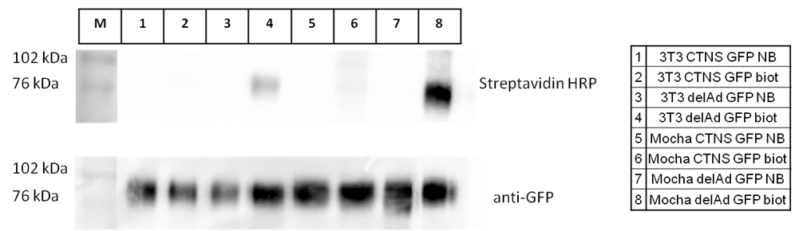

Figure 1: Cell surface biotinylation in 3T3 and Mocha fibroblasts. After cell surface biotinylation, the total cell lysates were immunoprecipitated using anti-GFP beads. The western blots of samples after immunoprecipitation revealed with streptavidin-HRP or anti-GFP antibody are shown.

Furthermore we generated HeLa cells transduced with lentivirus containing shAP3 or shLuciferase (shRNA vectors kindly provided by A. Benmerah), which enables us to analyze the localization of cystinosin and its targeting motif deletion mutants after transient transfection. We performed cell surface biotinylation analysis 20h and 48h after transfection of cystinosin-GFP, cystinosin deleted for its C-terminal tail (delAd-GFP) or its 5th inter-TM loop signal (delYA-GFP) (Fig.2). We could observe the increase of cell surface expression for all the constructs in HeLa shAP3 cells 20h after transfection. Interestingly, this increase could no longer be detected for cystinosin-GFP 48h after transfection, while it remained increased for both deletion mutants in cells depleted for the AP3 complex. These data could indicate the importance of both targeting motifs in cystinosin trafficking via AP3 dependant pathway. Moreover, it seems that both motifs could also play a role in a rapid internalization of cystinosin from the plasma membrane, once it is mislocalized, as only the biotinylated cystinosin-GFP can no longer be detected 48h after transfection. This could also explain the lack of signal of biotinylated cystinosin-GFP in stable Mocha cell lines.

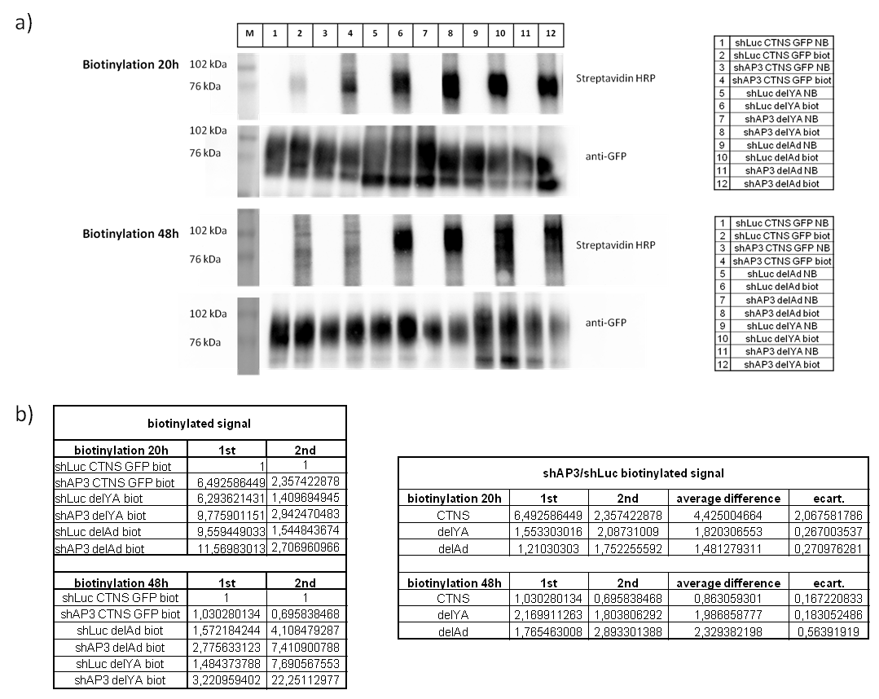
Figure 2: Cell surface biotinylation in HeLa shAP3 and HeLa shLuc 20h or 48h after transfection.
- Western blots of biotinylated samples. After cell surface biotinylation, the total cell lysates were immunoprecipitated using GFP coupled beads. The eluates were divided in two and revealed with streptavidin-HRP or anti-GFP antibody (NB-non biotinylaed, biot-biotinylated samples). Results from two separate experiments shown.
- The quantification of cell surface expression of cystinosin and its deletion mutants. The GFP signal on western blots was used for normalization.

To better analyze the importance of the C-terminal sequence of cystinosin in the targeting process, we generated a CD63-GFP chimeric protein containing the C-terminal tail of cystinosin (CD63-Cter-GFP). CD63 is a lysosomal tetraspanin with a classical tyrosin-based motif (GYEVM) interacting with AP2 and AP3 complexes (Dell’Angelica et al., MolBiolCell, 1999). We found that CD63-Cter-GFP was exclusively vesicular, while CD63-GFP was partially localized to the plasma membrane in HeLa cells. A similar increase in the intracellular localization of CD63 has already been observed after mutation of methionine into isoleucine in its tyrosine based motif, which no longer interacted with AP2 while the interaction with AP3 was maintained. The similarity of this mutated motif (GYEVI) to the one of cystinosin (GYDQL) further indicate its involvement in direct trafficking via AP3 pathway. Moreover, we observed the accumulation of CD63-Cter-GFP in the Golgi compartment in HeLa cells depleted in AP3, whereas no difference in colocalization with Golgi markers, GM130 and Rab6, was observed for neither cystinosin-GFP nor CD63-GFP (Fig.3). This further supports our yeast two-hybrid results, suggesting that the cystinosin tyrosine-based motif alone could target proteins to lysosomes by interacting with the AP3 complex. In connection with the differences in the biotinylation of cystinosin-GFP at different times after transfection, we are now analyzing the possible Golgi retention of cystinosin-GFP, CD63-GFP and CD63-Cter-GFP 20h after transfection.

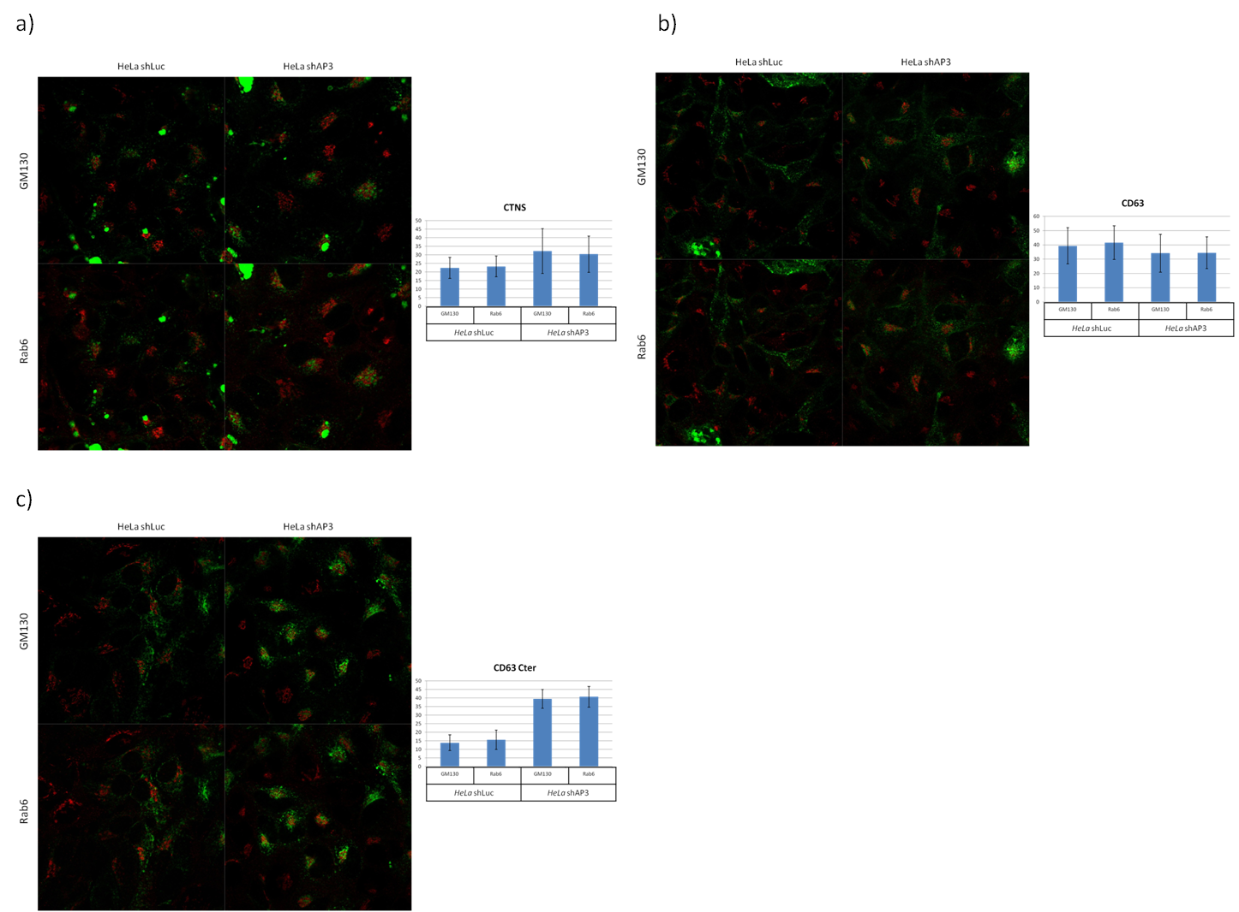
Figure 3: Colocalization of cystinosin-GFP (a), CD63-GFP (b) and CD63-Cter-GFP (c) with GM130 and Rab6 (red) in HeLa shAP3and HeLa shLuc cells.

Identification of cystinosin interaction partners

In order to get insight into the possible implication of the 5th inter-TM loop of cystinosin, this domain was used for a large screen against a mouse kidney cDNA library (collaboration with Hybrigenics). We identified different putative partners and focused on two of them: Vps39 and Snf8 (the murine homolog of Vps22) both being implicated in membrane fusion and trafficking respectively (Caplan et al, 2001; Progida et al, 2006). As we already reported, after verification of the results of yeast two hybrid screen by performing a direct yeast two hybrid screen in the laboratory we were able to confirm interactions of the 5th inter-TM loop of cystinosin only with SNF8 and Mad2l2. As Mad2l2 is a nuclear protein that would not be expected to interact with cystinosin in physiological conditions we are now trying to confirm the possible interaction with SNF8. For this purpose we prepared the construct for production of SNF8-GST fusion protein. We validated our GST pull down assay by showing the interaction of SNF8-GST with its known partner RILP (RILP gfp construct kindly provided by C. Progida; Progida C. et al., 2006). However, we encountered some problems in optimization of pull down conditions for cystinosin-GFP and cystinosin-HA, as signals for these proteins could be observed also in eluates after pull down with GST alone, thus we could not definitely conclude for the presence of the interaction with SNF8.

References:

- Caplan S, Hartnell LM, Aguilar RC, Naslavsky N, Bonifacino JS, Human Vam6p promotes lysosome clustering and fusion in vivo. JCB 154(1): 109-121, 2001
- Cherqui S, Kalatzis V, Trugnan G, Antignac C, The targeting of cystinosin to the lysosomal membrane requires a tyrosin-based signal and a novel sorting motif., JBC 276: 13314-13321, 2001
- Dell'Angelica EC, Shotelersuk V, Aguilar RC, Gahl WA, Bonifacino JS. Altered trafficking of lysosomal proteins in Hermansky-Pudlak syndrome due to mutations in the beta 3A subunit of the AP-3 adaptor., Mol Cell.;3(1):11-21., 1999

Furuta N, Fujita N, Noda T, Yoshimori T, Amano A, Combinational soluble N-ethylmaleimide-sensitive factor attachment protein receptor proteins VAMP8 and Vti1b mediate fusion of antimicrobial and canonical autophagosomes with lysosomes., Mol Biol Cell.; 15;21(6):1001-10; 2010
- Progida C, Spinosa MR, De Luca A, Bucci C, RILP interacts with the VPS22 component of the ESCRT-II complex, Biochem Biophys Res Commun. 347(4):1074-9, 2006
- Robinson MS, Bonifacino JS. Adaptor-related proteins., Curr Opin Cell Biol.13(4):444-53,2001
- Rous BA, Reaves BJ, Ihrke G, Briggs JA, Gray SR, Stephens DJ, Banting G, Luzio JP Role of adaptor complex AP-3 in targeting wild-type and mutated CD63 to lysosomes., Mol Biol Cell.;13(3):1071-82, 2002

