Eye-Targeted Gene Therapy for Cystinosis
Principal Investigator: Kang Zhang
Co-Principal Investigator: Stephanie Cherqui

Background
Eye complications of cystinosis are frequent and debilitating. Corneal cystine crystal deposits are pathognomonic for cystinosis in human patients [1] and are a virtually constant finding at the age of 1 year in cystinotic patients [2]. Electroretinographic study of 12 cystinotic patients demonstrated six normal, three “supernormal”, and three flat ERGs [1]. The severely impaired ERG correlates with the retinopathy observed in affected individuals from as early as three years of age, and which is almost constant after seven years of age [2]. This retinopathy is characterized by patches of depigmentation in the peripheral retina. These lesions tend to worsen and extend with time, eventually affecting the macula, which is responsible for the decrease in visual acuity [1].

Our Co-PI, Dr. Stephanie Cherqui, created the first mouse model of cystinosis by making a Ctns knockout mouse using a promoter trap approach [3]. Ctns^{-/-} mice accumulated cystine and cystine crystals in all of the organs tested. Ctns^{-/-} mice developed ocular changes similar to those observed in affected human patients [3,4].

Characterization of eye complications of cystinosis in a mouse model
We detected cystine crystals in the corneas of 5-month-old Ctns^{-/-} mice using optical coherence tomography (OCT). We have discovered a significant increase in IOP in these knockout mice. We performed non-invasive measurements of retinal functions in Ctns^{-/-} mice using ERG and found that there are significant decreases in scotopic (rod), photopic (cone) and mixed ERG responses.

In vivo gene transfer studies
We want to test if intrastromal injection of AAV-CTNS into the cornea allows a prolonged CTNS gene expression lasting for several months up to one year, which might therefore be an alternative to daily frequent cysteamine eye drops.

Characterization of gene therapy vectors and corneal gene transfer studies
We constructed AAV2-CTNS and AAV2-GFP vectors by cloning the CTNS cDNA or GFP into a transfer plasmid and then completing AAV2-vector production. We outsourced AAV2-CTNS and AAV2-GFP vector production to the Gene Therapy Center of the University of North Carolina, an established national gene therapy vector facility. We injected AAV2-based vectors for our study into wild type mouse corneas. However, we found that AAV2-based vectors had a very low level of transduction efficiency into corneal keratocytes. We therefore switched our vector to an AAV8-based vector, based on literature and communication with other cystinosis research groups. We have now obtained highly efficient transduction of an AAV8-GFP vector that resulted in high levels and uniform expression of reporter gene GFP (Fig. 1). We have also produced an AAV8-CTNS vector and we are currently injecting it into wild type and Ctns^{-/-} mice to test its efficacy in preventing, reducing, or eradicating crystals in corneas of Ctns^{-/-} mice.

PROGRESS REPORT
In vivo corneal gene transfer studies
After obtaining highly efficient transduction of an AAV8-GFP vector that resulted in high intracorneal levels and uniform expression of reporter gene GFP, we produced an AAV8-CTNS vector that we injected into wild type (C57BL6) and Ctns^{-/-} mice to test its efficacy in preventing, reducing, or eradicating crystals in corneas of Ctns^{-/-} mice.

We have successfully performed intracorneal injections of AAV8-CTNS in 19 Ctns^{-/-} mice ranging from 1.5 to 4.5 months of age. We have also injected two 2 month old wild type mice with AAV8-GFP for long term monitoring. We have performed intracorneal injections of AAV8-GFP into Ctns-/- age-matched control mice to confirm that any benefits obtained from the AAV8-CTNS injections are due to CTNS gene transfer rather than an effect of the AAV8 virus.

Materials and Methods
Animals: Ctns-/- mice from the Cherqui Laboratory at The Scripps Research Institute and C57BL6 mice from the Jackson Laboratory, USA were used to test the efficacy and safety of the AAV8-CTNS vector in gene transfer studies. Animals were cared for and handled according to the Association for Research in Vision and Ophthalmology (ARVO) statement for the use of animals in vision and ophthalmic research, and with Institutional Animal Care and Use Committee (IACUC) approved protocols.

Anesthesia: A mixture of ketamine (150 mg/kg intraperitoneal (IP)) and xylazine (10 mg/kg IP) was used for anesthesia during the procedure. Each mouse’s head was secured and positioned with a stereotactic head holder. Proparacaine 0.5% was used as an ocular topical anesthetic. The total duration of the procedure, beginning with anesthesia, through recovery of the animal, was less than 40 minutes. Mice were observed post-operatively for signs of infection or distress.

Intrastromal corneal injections: AAV8-CTNS vector was delivered by a single intrastromal corneal injection of 2.0 µL (vector titer= 2x10¹¹) into one eye of each mouse being studied. The contralateral eye received no injection. With the aid of a binocular operating microscope, the injections were completed by first using a 31-gauge needle to create a tunnel into the peripheral corneal stroma, with care being taken not to puncture the cornea. A Hamilton micro-syringe was then positioned into the tunnel site, and 2.0 µL of viral vector was delivered. Successful injection was gauged by observing that ≥70% of the cornea became whitened and edematous immediately following the injection (edema resolves within approximately 12 hours following injection). Antibiotic eye drops and lubricating gel were administered after the procedure.

We are currently using electroretinography, tonometry, optical coherence tomography, ocular slit-lamp examination, corneal histology, and corneal cystine analysis as measures for efficacy and safety in this viral vector mediated gene transfer study.

References

1. Dufier, J.L., et al., Ocular changes in long-term evolution of infantile cystinosis. Ophthalmic Paediatr Genet, 1987. 8(2): p. 131-7.
2. Dufier, J.L., Ophthalmologic involvement in inherited renal disease. Adv Nephrol Necker Hosp, 1992. 21: p. 143-56.
3. Cherqui, S., et al., Intralysosomal cystine accumulation in mice lacking cystinosin, the protein defective in cystinosis. Molecular & Cellular Biology, 2002. 22(21): p. 7622-32.
4. Kalatzis, V., et al., The ocular anomalies in a cystinosis animal model mimic disease pathogenesis. Pediatr Res, 2007. 62(2): p. 156-62.

Figures and Legends
Figure 1
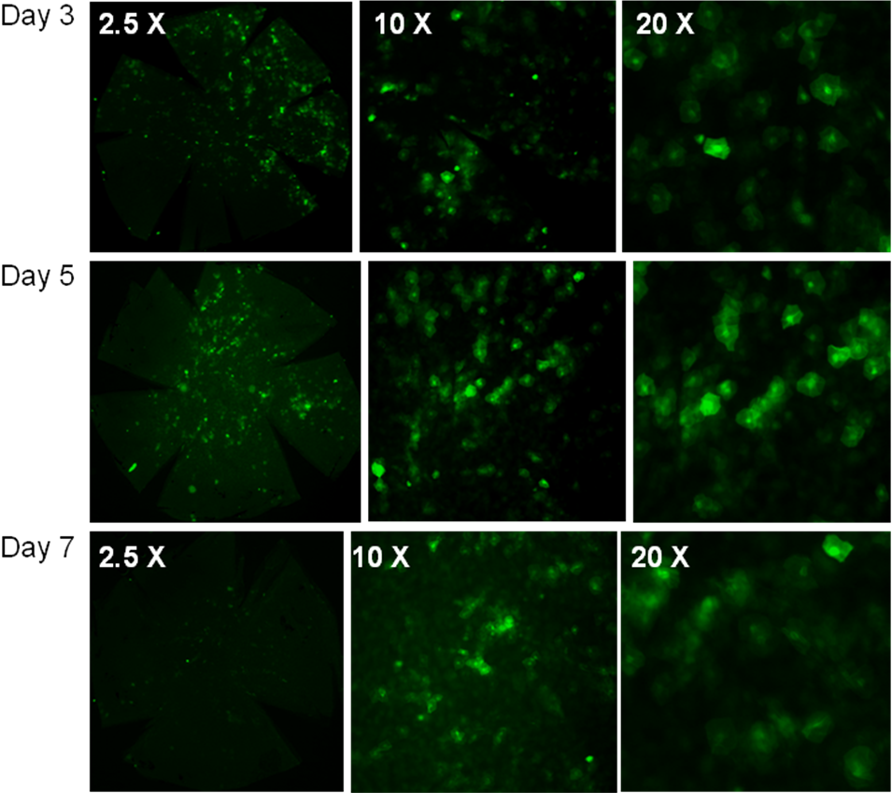
Fig. 1. Expression of GFP derived from an AAV8-GFP vector. Photographs were taken after day 3, day 5, or day 7 post intrastromal injection of vector into wild type mice corneas. There was strong and uniform expression of GFP using this AAV8-based vector. Almost all keratocytes were infected.

