Eye-Targeted Gene Therapy for Cystinosis in the Eye
Principal Investigator: Kang Zhang
Co-Principal Investigator: Stephanie Cherqui

Background
Eye complications of cystinosis are frequent and debilitating. Corneal cystine crystal deposits are pathognomonic for cystinosis in human patients [1] and are a virtually constant finding at the age of 1 year in cystinotic patients [2]. Electroretinographic study of 12 cystinotic patients demonstrated six normal, three “supernormal”, and three flat ERGs [1]. The severely impaired ERG correlates with the retinopathy observed in affected individuals from as early as three years of age, and which is almost constant after seven years of age [2]. This retinopathy is characterized by patches of depigmentation in the peripheral retina. These lesions tend to worsen and extend with time, eventually affecting the macula, which is responsible for the decrease in visual acuity [1].

Our Co-PI, Dr. Stephanie Cherqui, created the first mouse model of cystinosis by making a Ctns knockout mouse using a promoter trap approach [3]. Ctns^{-/-} mice accumulated cystine and cystine crystals in all of the organs tested. Ctns^{-/-} mice developed ocular changes similar to those observed in affected human patients [3,4].

Characterization of eye complications of cystinosis in a mouse model
We detected cystine crystals in the corneas of 5-month-old Ctns^{-/-} mice using optical coherence tomography (OCT). We have discovered a significant increase in IOP in these knockout mice. We performed non-invasive measurements of retinal functions in Ctns^{-/-} mice using ERG and found that there are significant decreases in scotopic (rod), photopic (cone) and mixed ERG responses.

In vivo gene transfer studies
Our hypothesis is to test if intrastromal delivery of AAV-CTNS into the cornea allows a prolonged CTNS gene expression lasting for several months up to one year, which might therefore be an alternative to daily frequent cysteamine eye drops.

Characterization of gene therapy vectors and corneal gene transfer studies
We constructed AAV2-CTNS and AAV2-GFP vectors by cloning the CTNS cDNA or GFP into a transfer plasmid and then completing AAV2-vector production. We outsourced AAV2-CTNS and AAV2-GFP vector production to the Gene Therapy Center of the University of North Carolina, an established national gene therapy vector facility. We injected AAV2-based vectors for our study into wild type mouse corneas. However, we found that AAV2-based vectors had a very low level of transduction efficiency into corneal keratocytes (Fig. 1). We therefore switched our vector to an AAV8-based vector, based on literature and communication with other cystinosis research groups. We have now obtained highly efficient transduction of an AAV8-GFP vector that resulted in high levels and uniform expression of reporter gene GFP (Fig. 2).

Future Plan
We have produced an AAV8-CTNS vector and we plan to inject it into wild type and Ctns^{-/-} mice to test its efficacy in preventing, reducing, or eradicating crystals in corneas of Ctns^{-/-} mice. We have injected this vector in 6 Ctns^{-/-} mice, and are following them with OCT and electrophysiology.

References

1. Dufier, J.L., et al., Ocular changes in long-term evolution of infantile cystinosis. Ophthalmic Paediatr Genet, 1987. 8(2): p. 131-7.
2. Dufier, J.L., Ophthalmologic involvement in inherited renal disease. Adv Nephrol Necker Hosp, 1992. 21: p. 143-56.
3. Cherqui, S., et al., Intralysosomal cystine accumulation in mice lacking cystinosin, the protein defective in cystinosis. Molecular & Cellular Biology, 2002. 22(21): p. 7622-32.
4. Kalatzis, V., et al., The ocular anomalies in a cystinosis animal model mimic disease pathogenesis. Pediatr Res, 2007. 62(2): p. 156-62.

Figures and Legends

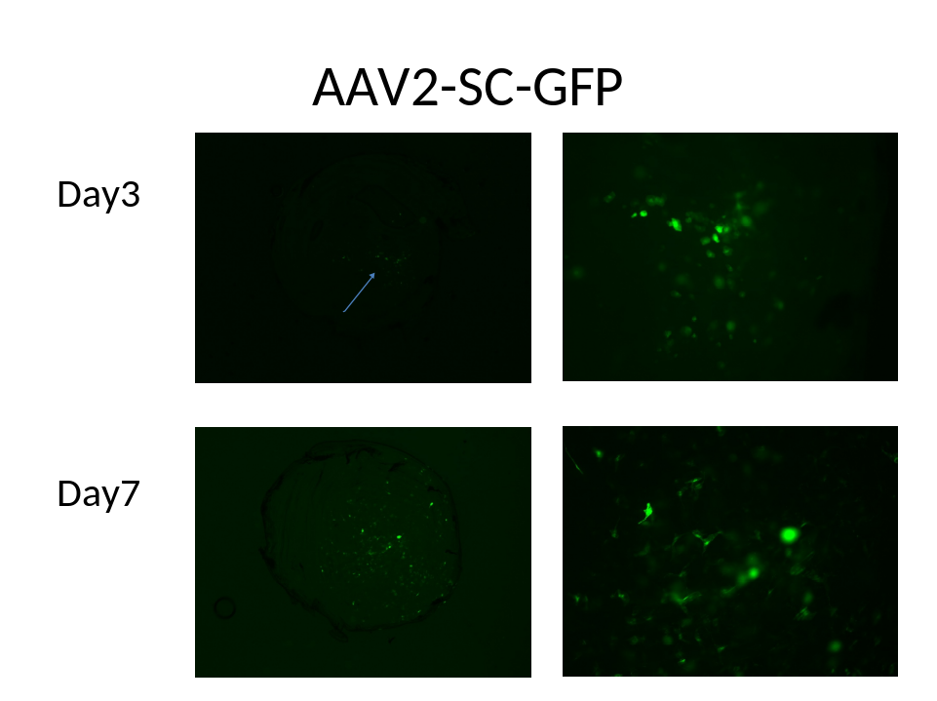
Fig. 1. Expression of GFP in keratocytes derived from an AAV2-SC-GFP vector. Photographs were taken after day 3 or day 7 post intrastromal injection of vector. Less than 30% of keratocytes were infected. There was modest expression of GFP using this AAV2-based vector.

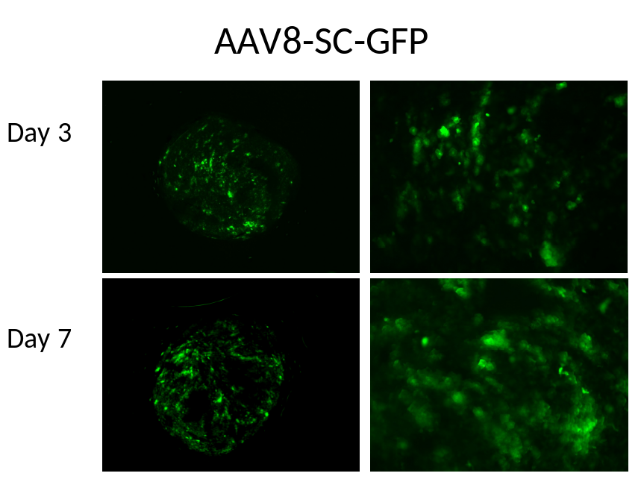
Fig. 2. Expression of GFP derived from an AAV8-SC-GFP vector. Photographs were taken after day 3 or day 7 post intrastromal injection of vector. There was strong and uniform expression of GFP using this AAV8-based vector. Almost all keratocytes were infected.

